**Module 4** **Empirical Exercise**

Jingxuan Zhao

In this assignment, I used 3 different measures to quantify hospital market shares and examined the associations between market concentration and price. I obtained hospital financial and discharge data from Hospital Cost Report Information System. When defining the market by zip code, I found that most hospitals had 0-50% or 90%-100% of the market share from 2000-2017 (Figure 1). When defining the market by HRR or community detection algorithms, I found that most hospitals had relatively low (<10%) of market share (Figures 2-3). When examining the association of market concentration with hospital price, I found that higher market concentration was associated with higher hospital price when market was defined by HRR. No significant associations of market concentration and hospital price were observed when defining market by zip code of communities defined by community detection algorithms. When quantifying the price elasticity, I found a negative association of hospital price and market shares when markets were defined by zip code, HRR, and CDA. A smaller magnitude of the association was observed for markets defined by zip code comparing to markets defined by HRR and CDA.

Please refer to the ‘readme’ file and R codes for more information on the codes and analysis

**Question 1**

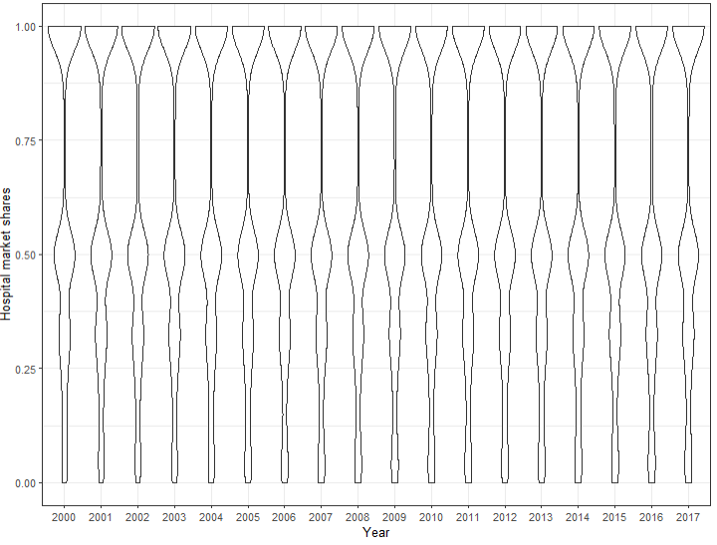

**Figure 1**. Distribution of market shares over time by zip code.

**Question 2.**

**Table 1**. Association between market concentration and price when market was defined by zip code

|  |  |
| --- | --- |
|  | Model estimate |
| HHI | 1.22 (2.84) |
| Hospital total discharge | -0.003 (0.003) |
| Number of hospitals within a market | 12624 (11173) |
| R^2 | 0.560 |

**Question 3**

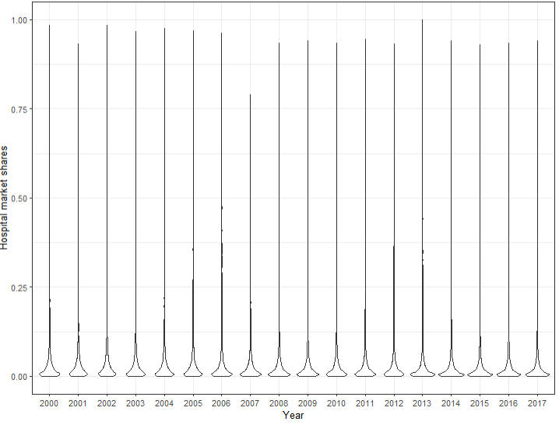

**Figure 2**. Distribution of market shares over time by hospital referral region.

**Question 4**

**Table 2**. Association between market concentration and price when market was defined by zip code

|  |  |
| --- | --- |
|  | Model estimate |
| HHI | 5.73 (2.01) *** |
| Hospital total discharge | -0.004 (0.002) |
| Number of hospitals within a market | -42 (142) |
| R^2 | 0.626 |

*** indicates p<0.001

**Question 5**

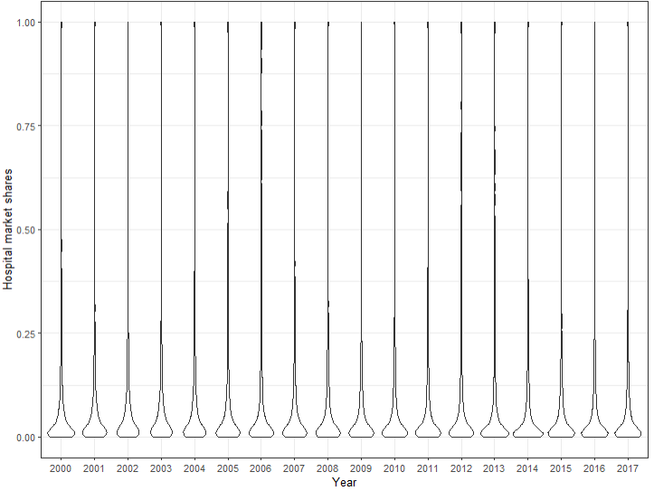

**Figure 3**. Distribution of market shares over time by market based on the community detection algorithms.

**Question 6**

**Table 3**. Association between market concentration and price when market was defined by zip code

|  |  |
| --- | --- |
|  | Model estimate |
| HHI | -0.205 (0.618) |
| Hospital total discharge | -0.001 (0.001) |
| Number of hospitals within a market | 25.8 (91.2) |
| R^2 | 0.636 |

**Question 7**

**Table 4.** Price elasticity estimated by logit discrete choice model using market share data.

|  |  |  |  |
| --- | --- | --- | --- |
|  | Zip code | HRR | CDA |
| Log(price) | -0.15 (0.03) *** | -0.70 (0.02) *** | -0.66 (0.02) *** |
| R^2 | 0.903 | 0.971 | 0.912 |

*** indicates p<0.001

**Question 8**

When defining the market by zip code, I found that most hospitals had 0-50% or 90%-100% of the market share from 2000-2017 (Figure 1). When defining the market by HRR or community detection algorithms, I found that most hospitals had relatively low (<10%) of market share (Figures 2-3). The results look reasonable to me as HRR and market defined by CDA are relatively large area and each hospital may have smaller share within each market.

When examining the association of market concentration with hospital price, I found that higher market concentration was associated with higher hospital price when market was defined by HRR. No significant associations of market concentration and hospital price were observed when defining market by zip code of communities defined by community detection algorithms. This is not very surprising to me after the class discussion on the potential issue of using HHI to predict hospital price.

When quantifying the price elasticity, I found a negative association of hospital price and market shares when markets were defined by zip code, HRR, and CDA. A smaller magnitude of the association was observed for markets defined by zip code comparing to markets defined by HRR and CDA.

**Question 9**

I feel this is the easiest assignment comparing to the earlier three in this semester. The most challenging part is how to define hospital price. I could not find much information from a quick search. I’m not sure if the approach I choose is correct. The results from 3 models examining the associations of HHI and price is not very surprising to me after the class discussion on the potential issue of using HHI to predict hospital price.

**Question 10**

The 4 empirical exercises took a lot of time, but definitely worth it. I hope we can get all instructions at the very beginning instead of getting updates for some details and need to redo the data cleaning.

Most of the topics from the required readings and presentations are interesting to me. But I feel the schedule is a little bit tight if 3 of us need to present in 75 minutes. 2 will be better.

One topic I would like to learn but not covered is payment model. I guess a lot of them are more related to public health and health policy. But I’m interested in learning how economists think about it.